Hand Written Character Recognition
[DIP Project]
Ravi Balaji A J

Abstract (Intro):
Handwriting recognition is one of area pattern recognition. The purpose of pattern recognition is to categorizing or classification data or object of one of the classes or categories. Handwriting recognition is defined as the task of transforming a language represented in its spatial form of graphical marks into its symbolic representation. Each script has a set of icons, which are known as characters or letters, which have certain basic shapes. The goal of this project is to identify input characters or image correctly using Open-CV and machine learning.

Handwriting recognition has been one of the most fascinating and challenging research areas in field of image processing and pattern recognition in the recent years. It contributes immensely to the advancement of an automation process and can improve the interface between man and machine in numerous applications

Challenges and (what method I used!):
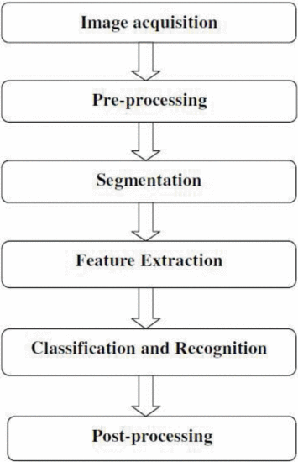
Pre-Processing & Segmentation part is done by using open-cv python, where the specific idea is convert the input image to B/W and slightly blurring to remove sharp edges after that Segmentation is done by finding contour in the pre processed image, where we will get each and every character(letter) separately.
For Feature extraction I used HOG (Histogram of Oriented Gradients) feature descriptor which gives the feature based on the image gradient magnitude and gradient direction of every part of the image.
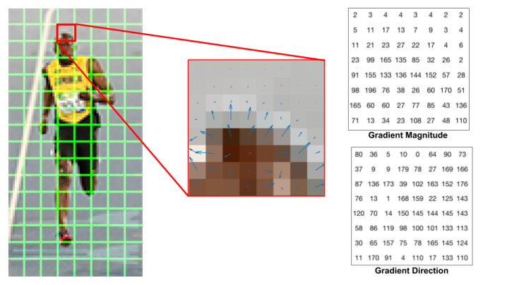
Finally used ML to train, classify and recognize the Handwritten Characters of the given Input image. Training set is taken from internet which contains around 55 images for all character ([0-9], [A-Z], [a-z]).
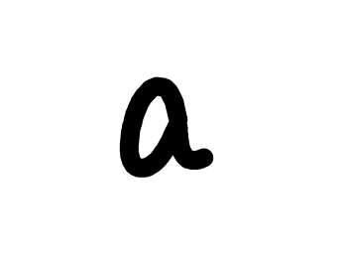

State of Art:

At this point of time, my code can detect letters from an image and recognize them as original characters with an accuracy of 73.444% (Random Forest Classifier)
And also this is only applicable for non-joined words, because I’m using contour detecting mechanism. (Character like ‘i’ and ‘j’ are not detected by findcontour() because they are of two separate images, hence they aren’t recognised)

References:

- https://www.learnopencv.com/handwritten-digits-classification-an-opencv-c-python-tutorial/

- http://hanzratech.in/2015/02/24/handwritten-digit-recognition-using-opencv-sklearn-and-python.html

- https://www.learnopencv.com/histogram-of-oriented-gradients/

Test Cases:

- Perfectly Recognised
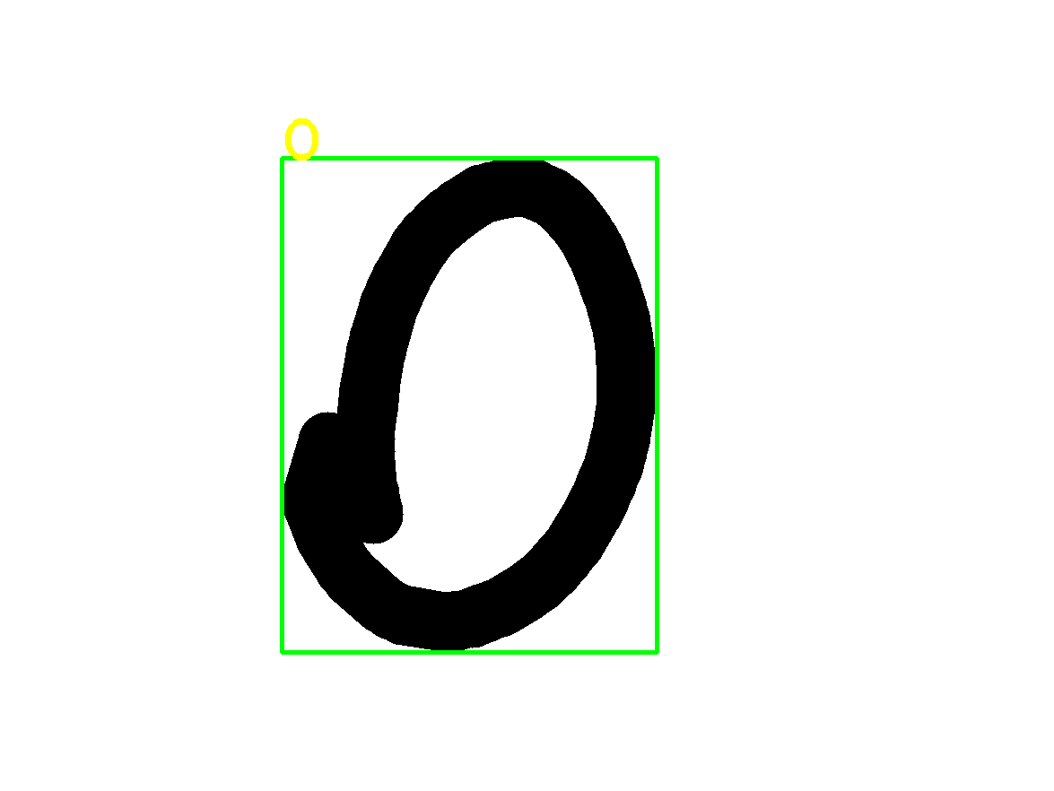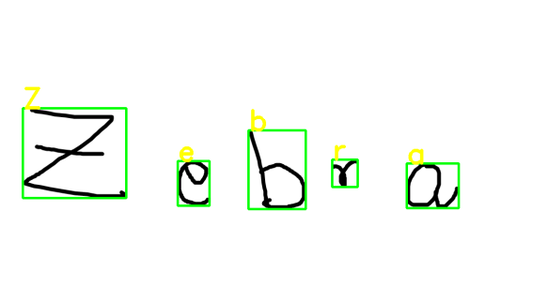
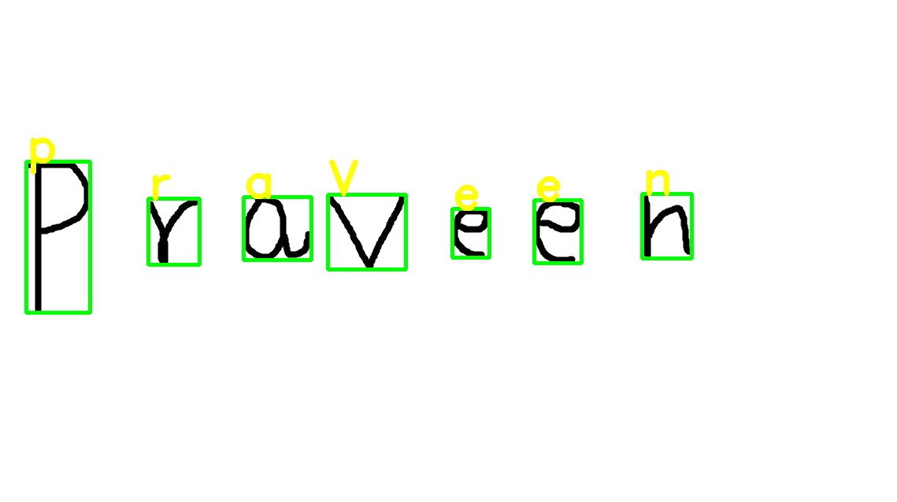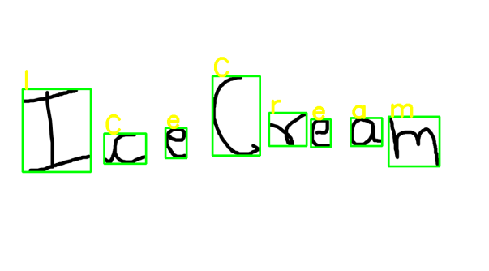
- Problematic:

